Archive Tour 2016
Sunday started off in typical Highveld sunshine and ended in typical Cape rain. But this did not dampen our spirits at all as we set off with members of Western Cape Branch for a tour of the West Coast. We drove up as far as Malmesbury, visiting Philadelphia and Vissershok en route. Lots were drawn for partners in the bus which was a great way to meet new people and we all found plenty to talk about.
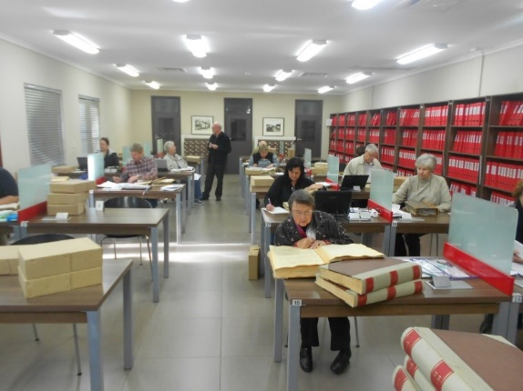
Monday saw us off on our first visit. A twenty minute amble up the road to the Archives where we were welcomed by Jaco and Erica. The weather was still damp and miserable so we had the Archives virtually to ourselves which was a great advantage. We all handed in our requests and then Jaco took us on a tour of the Archives. What an eye opener. Miles and miles of records in a building purpose built and with each row of files on a reinforced beam.

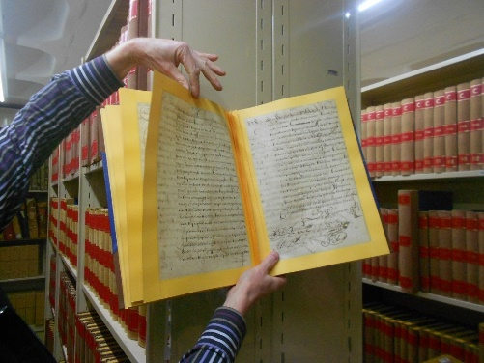
I was able to find more tales about some of our illustrious ancestors. I discovered that one who had “retired due to ill-health” had in fact been fired! I never found out why, but did discover that he wrote and asked if he could come and collect the barley and oats he had planted as he had used his own money to buy the seeds! Stories like that make our family history come alive – our ancestors were real people, just like us.

I know that Doreen was very excited when she found her great great grandfather’s marriage entry. He had come out to SA from Scotland in 1817 with the Moodie group.

One morning Ellen and I walked across to the Deeds Office in Plein Street. This was a new experience for Ellen and I must say we were well received. We were taken on a tour by Amanda Meko and then I was able to request three Transfer Deeds. By the time I had paid the required fee, copies were ready and waiting. Amazing service!

Talking of amazing service, at the Cape Town Archives I was able to have 12 photographs downloaded onto a flash drive within half an hour of requesting them. Admittedly these were ones that had already been digitized.

On the way to the Deeds Office we passed the site of my grandfather’s chemist shop. The façade has been preserved but the inside had been gutted and was being rebuilt. We walked in and spoke to the builders who then let us walk upstairs and take some photos. More stories for my family history!

On the Wednesday, we went across to Stellenbosch where the staff of GISA had everything ready and waiting. Ellen had told them what each person wanted so it was all laid out. I had requested a copy of a book but as it was a digital copy by name was alongside a computer where a push of the button brought up the book.

When I had finished at GISA the bus driver offered to drive some of us around the area while the rest of the group were still hard at work. Off we went into the mountains towards the Helshoogte Pass. Beautiful scenery, flowers and even some snow in the distance.

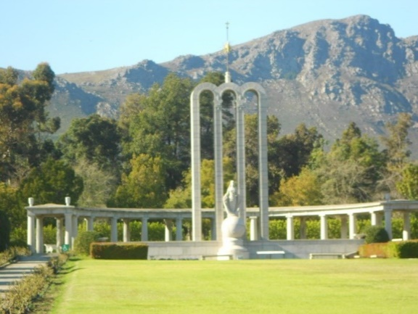
On our last day we left the hotel early and headed for Franschhoek where we visited the Huguenot Memorial and Archives. Once again the staff had done us proud and everything was waiting in the reading room.

After a delicious lunch in Franschhoek we headed west towards Paarl, stopping along the way at the Victor Verster prison. After a short break we carried on to the Taal Monument located on a hill overlooking Paarl.

Then it was back into the bus and on to Cape Town International Airport. We said fond farewells to those who were staying on and the rest of us made our way into the airport and home.

I really enjoyed the tour. The people were all very friendly; those in our group, at the hotel, on the bus, on the street and every one we met in all the archives. Robert (I think it was him) remarked that, in Cape Town, even the policemen greet you!

Would I go again. Yes. Definitely. I hope to be able to go again next year and I am sure I will find some more stories to add to my family history.

Lastly (and not leastly!) thanks must go to Ellen for organising every last detail. Without her the tour would never had been so successful – so thank you Ellen and see you in Cape Town next year.

